Problem Definition :
Create a student registration form with HTML5 input types and JavaScript validation for name, email, mobile number, password, confirm password, course, year, gender, and terms acceptance. Use Regular Expression for validations.

A.Theory :

1. Are correct input types and attributes used?
Yes. Appropriate input types such as email, password, text, and tel should be used. Attributes like required, placeholder, minlength, and maxlength help ensure that users enter valid information.
2. Are validation errors displayed near the relevant fields?
Yes. Validation errors should be displayed close to the corresponding input field. This makes it easy for users to understand what is wrong and how to correct it.
3. Is password strength checked?
Yes. Password strength can be checked by verifying requirements such as minimum length, uppercase and lowercase letters, numbers, and special characters. A clear strength indicator can also help users create stronger passwords.
4. Is the form accessible using keyboard and screen-reader-friendly labels?
Yes. The form should be fully usable with a keyboard, with logical tab navigation and visible focus indicators. Each input should have a properly associated <label> so screen readers can identify the purpose of the field.

B.Output :
Register :
1. Live Checker:
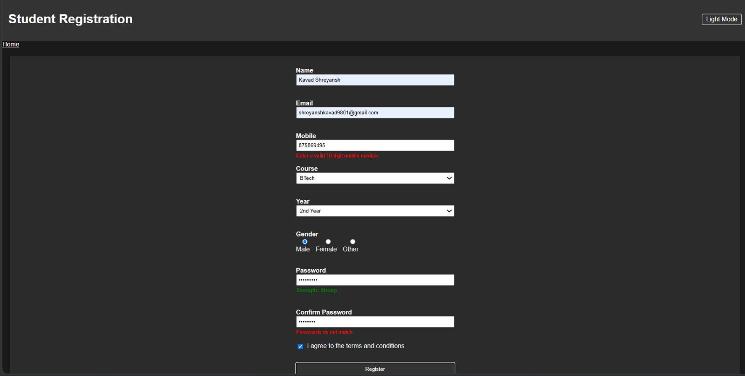

2. Alert Massage :
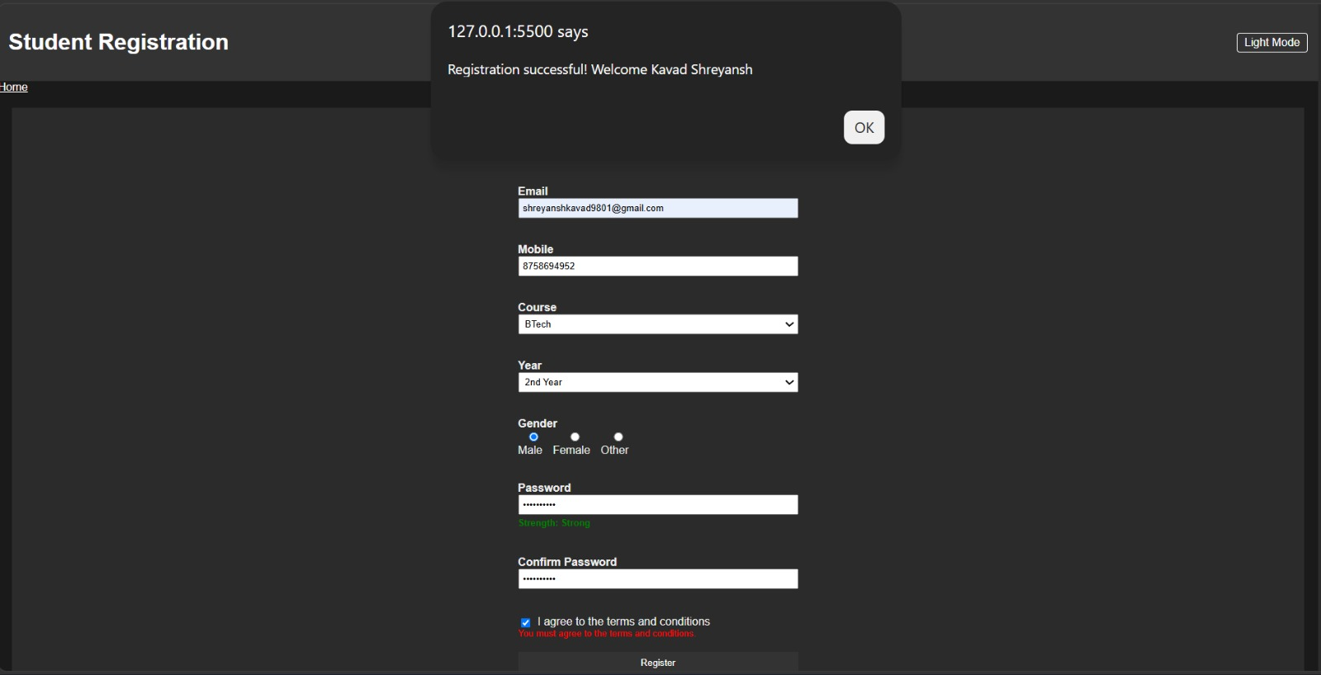

C.Learning Outcome :
Learned to write regular expressions (regex) to validate real-world inputs like email, mobile number, and name format
Learned to display field-specific error messages instead of one generic alert, improving usability.
Github Repository :
https://github.com/Shreyansh2210/Web-Devlopment

Faculty Remarks :

